Norfolk Bowmen’s
5th Annual Double Wand
Sunday 26th July
10.30am

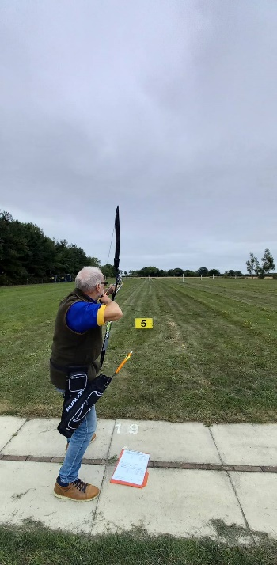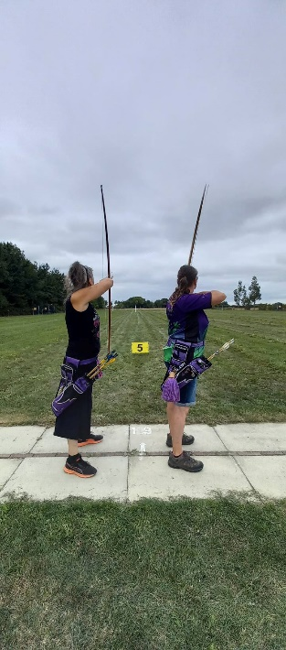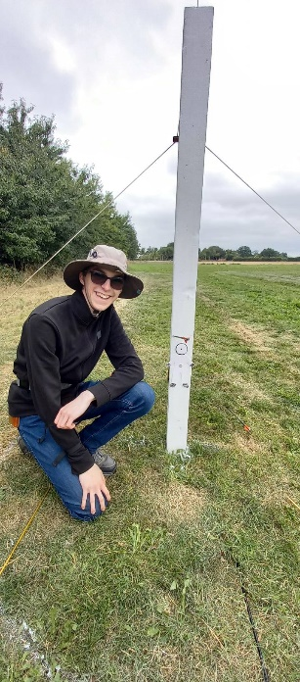

Gents 100 yards
Ladies 80 yards
Junior/ Novices 60 yards
Sorry no Compounds
Bacon Rolls and cold drinks available
Free tea and Coffee
Raffle
Ice cream van will be attending

