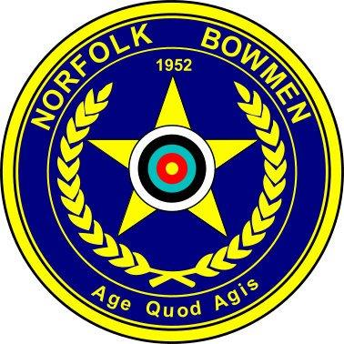

CLOUT SHOOT

Sunday 27th September 2026

Venue: The Long Meadow, Rectory Road,
Weston Longville, Norwich. NR9 5LG
Organiser:
Assembly: 10:15 Sighters: 10:30

Awards: Bragging Rights
Fees: Entry fee £0.00
Closing date for entry: Wednesday 23rd September 2026

Entries to: events@norfolkbowmen.co.uk

Tel: 07392 009391

Norfolk Bowmen Club Clout Shoot 2026
25/08/2025

Club:_________________________________ Contact No:_________________________
Name | Membership No | M/F | Sen/Jun | Rec/LB/BB/  Comp | Bacon Rolls £1.50 | Fee including Food

Email: _______________________________________________________________
I agree for information given on this form to be used for the running of this event
and used for the publication of target lists and results. Please tick:

Signature of Parent/Guardian for junior entrants: ______________________________

